AF 52
Synopsis

DESIGN AND DEVELOPMENT OF DCS KIDS:
AN INTERACTIVE WEB-BASED LEARNING MANAGEMENT SYSTEM FOR CHILDREN
Submitted in partial fulfilment of the requirements of the degree of
Bachelor of Engineering of Technology
In
ELECTRONICS AND COMPUTER SCIENCE ENGINEERING

By

AMANDEEP GOUND [EU1213006]
MAVIYA KHOT [EU1237029]
IRFAN MANSURI [EU1237048]

Under the Guidance of
(Prof. SURESH KANCHARLA)
Designation, Department, SJCEM



DEPARTMENT OF ELECTRONICS AND COMPUTER SCIENCE
ST. JOHN COLLEGE OF ENGINEERING & MANAGEMENT
UNIVERSITY OF MUMBAI
2026-2027



Certificate of Approval

This is to certify that AMANDEEP GOUND, IRFAN MANSURI and MAVIYA KHOT, are bonafide students of B. Tech in Electronic & Computer Science - Department, St. John College of Engineering and Management, Mumbai. They have satisfactorily completed the requirements of Synopsis as prescribed by ST. JOHN COLLEGE OF ENGINEERING AND MANAGEMENT (An Autonomous College affiliated to University of Mumbai), while working on “Design and Development of DCS Kids: An Interactive Web-Based Learning Management System for Children”.

Signature:  Name: Prof. Suresh Kancharla  Project Guide, | Signature:  Name: Dr. Md. Imaduddin  HOD,

Signature:
Name : Dr. Kamal Shah Principal,
St. John College of Engineering and Management.

Declaration

We declare that this written submission represents our ideas in our own words and where others’ ideas or words have been included, we have adequately cited and referenced the original sources. We also declare that we have adhered to all principles of academic honesty and integrity and have not misrepresented or fabricated or falsified any idea/data/fact/source in my/our submission. We understand that any violation of the above will be cause for disciplinary action by the Institute and can also evoke penal action from the sources which have thus not been properly cited or from whom proper permission has not been taken when needed.
(Signature):
(AMANDEEP GOUND)

(Signature):
(MAVIYA KHOT)

(Signature):
(IRFAN MANSURI)

Date:

Acknowledgement
We express our sincere gratitude to all those who have directly and indirectly contributed to the successful preparation of this project synopsis.
We are deeply grateful to Dr. Kamal Shah, Principal, St. John College of Engineering and Management, for providing an excellent academic environment and the necessary facilities to undertake this project.
We extend our heartfelt thanks to the Dr. Md. Imaduddin, Head of the Department of Electronic & Computer Science Engineering for their constant encouragement, valuable suggestions, and continuous support throughout the preparation of this synopsis.
We would like to express our sincere appreciation to our project guide, Prof. Suresh Kancharla, for their invaluable guidance, constructive suggestions, technical expertise, and continuous motivation. Their encouragement and insightful feedback have been instrumental in shaping this project synopsis.
We also acknowledge all the faculty members and laboratory staff of the Department of Electronic & Computer Science Engineering for their timely assistance, cooperation, and technical support.
We sincerely thank Dynamic Computer School (DCS Academy) for providing us with the opportunity to study the DCS Kids learning platform and gain practical knowledge of web-based educational systems. We are grateful for their support and valuable exposure, which helped us understand the practical applications of a Learning Management System.
Finally, we express our heartfelt gratitude to our parents, family members, friends, and classmates for their constant encouragement, moral support, and cooperation throughout this work.

Group Members
- AMANDEEP GOUND
- MAVIYA KHOT
- IRFAN MANSURI

ABSTRACT

DCS Kids is proposed as an interactive web-based Learning Management System designed to support children in learning through structured educational content and simple practice activities. The existing platform provides learning resources and interactive sections in areas such as Mathematics, English and basic computer education. The Mathematics section includes activities such as multiplication, division, number in words, square and cube, mental mathematics, counting and missing-number exercises. The English section includes A–Z learning, missing letters, missing words, short words, dictionary, word scramble and thesaurus activities.
The major project focuses on studying, organizing and presenting this learning platform as a structured LMS architecture. The proposed system separates the learning interface, educational modules, activity logic and data-management layer so that the platform can be extended in the future. The system aims to provide children with an easy-to-use environment where learning content can be accessed through a web browser and practice can be performed through interactive activities.
The project methodology includes requirement analysis, interface study, module identification, system architecture design, database and backend planning, frontend development, activity integration, testing and performance evaluation. The proposed system can be extended with student profiles, progress tracking, teacher/admin management, score history, personalized recommendations and gamification features.
The expected outcome is a child-friendly LMS that improves accessibility and organization of digital learning resources while providing a foundation for future analytics and personalized learning. The project is software-oriented and therefore emphasizes usability, maintainability, modular design and scalability.

C O N T E N T S

- List of Figures i
- List of Tables ii
- Abbreviations and symbols iii

Chapter No. | Topic | Page No.
Chapter 1 | Introduction: Background, Problem Statement, Need, Objectives, Scope, Expected Outcomes | 4
Chapter 2 | Literature Review: Survey table, Research Gap, Novelty/Innovation | 7
Chapter 3 | Proposed Methodology: Proposed System, Working Principle, Architecture, Flow Chart, Methodology, Components | 10
Chapter 4 | Project Planning: WBS, Gantt Chart, Roles, Risk Assessment | 19
Chapter 5 | Resources & Feasibility: Technical/Economic/Operational Feasibility, Budget, BOM | 22
Chapter 6 | Expected Results | 25
Chapter 7 | Sustainability & Impact: Industrial relevance, Societal and Environmental impact, SDG mapping | 26
Chapter 8 | Conclusion | 27
References | IEEE style; 18 references | 28

List of Figures

Figure No. | Figure Name | Page No.
1 | Block Diagram (System Architecture) | 12
2 | Flow Chart (Learning Workflow) | 13
3 | DFD – Level 0 | 14
4 | DFD – Level 1 | 14
5 | Use Case Diagram | 15
6 | ER Diagram | 16

List of Tables

Table No. | Table Name | Page No.
1 | Literature Survey | 7
2 | Components and Software Specification | 17
3 | Work Breakdown Structure | 19
4 | Gantt Chart | 20
5 | Roles and Responsibilities | 20
6 | Risk Assessment | 21
7 | Budget Estimation | 23
8 | Bill of Materials | 24
9 | Expected Results | 25

Abbreviations and symbols

LMS | Learning Management System
CRUD | Create, Read, Update, Delete
RBAC | Role-Based Access Control
DFD | Data Flow Diagram
ER | Entity–Relationship
UML | Unified Modeling Language
UI | User Interface
UX | User Experience
DCS | Dynamic Computer School
LMS | Learning Management System
A–Z | English Alphabet
+ | Addition
- | Subtraction
× | Multiplication
÷ | Division
= | Equal to

CHAPTER 1: INTRODUCTION

1.1 Background
Digital learning platforms have become an important complement to classroom teaching. A Learning Management System (LMS) is a web-based software application that organises learning content, delivers it to learners, records their activity and reports on their progress [4]. LMS adoption is widespread in higher education [3], but younger children have different needs: they require simple language, large touch-friendly controls, short interactive activities and immediate feedback, while parents and teachers need assurance that the child’s data is protected [7], [17].
DCS Kids (https://dcskids.dcsacademy.co.in/) is an online learning platform for young students hosted under the DCS Academy domain. According to its public pages, it aims to help children build skills in Maths, basic computer knowledge, English and other interactive programmes through kid-friendly lessons, activities and games. Its navigation menu lists Maths activities (Multiplication, Number in Word, Division, Square & Cube, Mental Maths, Count & Write) and English activities (Learn A to Z, Missing Letter, Missing Words, 2 Letter, 3 Letter, Dictionary, Word Scramble, Thesaurus), together with a Library page that groups these programmes.
The Home and Library pages and the navigation menu were reviewed for this synopsis (accessed on 19 October 2026). No student login, registration, dashboard, assessment record or progress report was visible on these public pages, and the source code, database and hosting configuration have not yet been inspected. This project therefore proposes to build on the existing DCS Kids identity and content to create a complete LMS, with every design decision subject to verification against the actual project files.

1.2 Problem Statement
- Existing problem: The public DCS Kids site appears to deliver standalone activities. No evidence was found of user accounts, saved results, a structured course hierarchy or progress reports, so a child cannot resume from where they stopped and teachers or parents cannot see how the child is performing.
- Industrial issue: General-purpose LMS products such as Moodle [2] are feature-rich but designed mainly for institutional and adult learners; they can be heavy to configure and are not child-friendly out of the box. Platforms that handle children’s data must also follow privacy obligations such as those in India’s Digital Personal Data Protection Act, 2023 [17].
- Research gap: Published LMS studies concentrate on adoption and acceptance, mostly in higher education [3], [5], [6]. Practical, implementation-level guidance for a lightweight, child-centred LMS that combines role-based access, server-side assessment and reliable progress tracking is limited.
- Need for improvement: DCS Kids needs a secure, database-driven back end with role-based dashboards, content management, validated assessments and persistent progress records, while keeping its child-friendly look and existing learning content.

1.3 Need of the Project
The project is important to several groups of stakeholders:
- Students can continue where they stopped, receive immediate feedback and see their own progress, which supports motivation and learning [10], [13].
- Teachers and administrators can manage courses, lessons and activities through a dashboard instead of editing page files, and can review results.
- Parents or guardians (if approved in scope) can view their own child’s progress without access to any other family’s data.
- The institution obtains a maintainable, secure platform that protects children’s personal information and can grow with new content.

1.4 Objectives
General objective: To design and develop a complete, functional, secure and responsive web-based Learning Management System for children, based on the existing DCS Kids platform.
Specific objectives:
- Analyse the existing DCS Kids website (and its source code, when access is provided) and document verified features, missing features and constraints.
- Design a normalised relational database and a modular architecture for users, courses, lessons, activities, assessments and progress.
- Develop secure authentication and server-side role-based authorisation for the roles confirmed in scope.
- Develop content-management and learning-activity modules following the structure Course → Unit → Lesson → Activity, together with quizzes that are scored on the server.
- Implement persistent progress tracking with student and administrator views (and teacher or parent views if approved).
- Test the system for functionality, security, privacy, usability and responsiveness, and document the results honestly.

1.5 Scope
Included in scope:
- Inspection of the existing website and, where access is granted, its source code, database and hosting setup.
- Role-based login and dashboards; course, lesson and activity management; publication controls.
- Interactive activities and quizzes with results stored in the database; basic performance summaries.
- Learning-progress tracking and administrator reports; a responsive interface for desktop, tablet and mobile.
- Automated and manual tests, and documentation (README, setup guide, architecture, DFD, ER, use case and workflow diagrams).
Limitations:
- The back end, database and hosting of the existing site are not verified; the final technology stack depends on this inspection.
- Teacher and parent modules are optional and will be built only if confirmed; no paid APIs, AI/ML, IoT or native mobile app are planned.
- Testing uses fictional demonstration data only; no real student records will be used or presented as production data.
Future expansion:
- Installable or native mobile app, notifications, multilingual content, badges and richer analytics, and integration with school systems (all outside the current scope).

1.6 Expected Outcomes
- A working, runnable DCS Kids LMS web application (software).
- Database schema, migration and seed scripts, with demonstration data clearly labelled as fictional.
- Automated and manual test suites, with results reported honestly.
- Documentation: README, setup instructions, and architecture, data-flow, ER, use-case and workflow diagrams.
- A possible publication or case study on a lightweight, privacy-aware LMS for children.
- Possible adoption by DCS Academy as its production learning platform

CHAPTER 2: LITERATURE REVIEW
2.1 Introduction
This chapter surveys literature on learning management systems, technology acceptance, educational applications for children, motivation and assessment, and web-security and privacy standards that are relevant to a children’s LMS. The sources range from foundational works to studies published in 2021; foundational works are included because they underpin design choices such as usability, feedback and cognitive-load reduction.
2.2 Literature Review Table
Table 1: Literature survey
Paper | Author | Year | Method | Findings | Research Gap
[1] Perceived usefulness, perceived ease of use, and user acceptance of information technology | F. D. Davis | 1989 | Empirical studies; Technology Acceptance Model (TAM) | Perceived usefulness and ease of use strongly influence whether users accept a technology. | Studied workplace users; does not address young children or learning platforms.
[2] Moodle: Using learning communities to create an open source course management system | M. Dougiamas, P. C. Taylor | 2003 | Design and description of an open-source course management system | Presented Moodle, built on a social-constructivist approach to online courses. | General-purpose and institution-oriented; not tailored to young learners’ interface needs.
[3] The current ecosystem of learning management systems in higher education | E. Dahlstrom, D. C. Brooks, J. Bichsel | 2014 | Survey of students, faculty and IT staff (EDUCAUSE ECAR) | Documented how LMS are used and perceived in higher education, where they are widely adopted. | Higher-education focus; no insight into child-centred LMS design.
[4] Learning management system (LMS) use with online instruction | V. M. Bradley | 2021 | Literature-based review | LMS reinforce learning through online classrooms; instructor presence supports engagement; learners can keep autonomy and motivation. Calls for scientific studies of LMS for subjects such as mathematics. | No concrete system design or implementation for young children.
[5] Application of LMS during the COVID-19 pandemic: a sustainable acceptance model | U. Alturki, A. Aldraiweesh | 2021 | Acceptance model tested with higher-education students | Students’ desire to use an LMS had beneficial effects on learning engagement during the pandemic. | University students; studies acceptance only, not features such as progress tracking or privacy.
[6] Determinants of learning management systems during COVID-19 pandemic for sustainable education | N. Cavus, Y. B. Mohammed, M. N. Yakubu | 2021 | AI-based modelling of LMS determinants (Nigeria) | Facilitating conditions, attitude, perceived enjoyment, satisfaction, usefulness and ease of use were the most significant factors. | Focuses on adoption factors in one country; no child-centred design or data-protection treatment.
[7] Putting education in “educational” apps: lessons from the science of learning | K. Hirsh-Pasek et al. | 2015 | Review of learning-science research applied to children’s apps | Good apps support active, engaged, meaningful and socially interactive learning toward a clear learning goal. | Evaluation framework only; no LMS with accounts, assessment and progress tracking.
[8] Does gamification work? A literature review of empirical studies on gamification | J. Hamari, J. Koivisto, H. Sarsa | 2014 | Literature review of empirical studies | Gamification generally gives positive effects, but outcomes depend on context and users. | Not specific to children’s LMS; limited evidence on long-term effects.
[10] Assessment and classroom learning | P. Black, D. Wiliam | 1998 | Review of research on classroom formative assessment | Feedback and formative assessment can raise learning standards. | Pedagogical evidence only; no software design for recording and reporting results.
[11] Multimedia Learning | R. E. Mayer | 2009 | Synthesis of experimental research | People learn better from words and pictures together when the design avoids unnecessary material. | Principles are not implemented in a working child-friendly LMS.
[12] Self-determination theory and the facilitation of intrinsic motivation | R. M. Ryan, E. L. Deci | 2000 | Review of research on motivation | Supporting autonomy, competence and relatedness fosters intrinsic motivation. | Needs translation into concrete LMS features such as choice, feedback and progress views.
[13] OWASP Top 10:2021 | OWASP Foundation | 2021 | Community-based ranking of web-application security risks | Lists leading risks including broken access control, cryptographic failures and injection. | General web guidance; must be applied to children’s data and LMS roles.

2.3 Research Gap
What previous researchers have done: studied LMS adoption and acceptance, mainly in higher education [1], [3], [5], [6]; built general-purpose LMS platforms [2]; established learning-science principles for educational apps, multimedia, feedback and motivation [7], [10]–[13]; and published web-security guidance [15].
What remains unsolved: few reports describe a lightweight, child-centred LMS that integrates role-based dashboards, server-validated assessments, persistent progress tracking and privacy-by-design, particularly for small academies that already run static learning content.
How this project addresses the gap: it applies these principles to a real platform (DCS Kids), extends the existing child-friendly site instead of replacing it, implements server-side authorisation and scoring, and separates verified requirements from assumptions with honest reporting of tests.

2.4 Novelty / Innovation
Innovative idea: an evidence-driven upgrade of a live children’s learning site into an LMS, preserving its identity and content rather than rebuilding from scratch.
Unique features: tracking of verified versus assumed requirements; authoritative server-side scoring; duplicate-free progress calculation; privacy-by-design for children’s data; optional teacher and parent modules enabled only when approved.
Improvements over existing systems: compared with the current site, the project adds accounts, saved results and dashboards; compared with general-purpose LMS platforms, it is simpler, child-friendly, lightweight and free of licence cost.

CHAPTER 3: PROPOSED METHODOLOGY
3.1 Proposed System
The proposed system is a web-based LMS that extends the existing DCS Kids website with a secure back end and database. Existing pages (Home, Library, Maths and English activities) are preserved and progressively integrated into a structured content model: Course → Subject/Unit → Lesson → Learning Activity.
Technology stack. The existing front end appears to be built from HTML pages using a Bootstrap-based template, and this will be retained. The back end, database and hosting environment cannot be determined from the public pages and will be verified when source access is provided. If no back end exists, the candidate stack is Python Flask with SQLAlchemy and MySQL, with credentials kept in environment variables. All choices will be confirmed against the hosting environment, and no paid service will be introduced without approval.
Main modules:
Authentication and account management: login and logout, hashed passwords, password reset, sessions and account status.
Role-based access control: server-side checks for the Student and Administrator roles; Teacher and Parent roles only if confirmed.
Course and content management: create, edit, order, publish and unpublish courses, units, lessons and activities.
Interactive learning activities: multiple-choice, true/false, matching, fill-in-the-blank, picture-based and reading activities, prioritising those already on the site.
Assessment service: questions, options, marks, attempt limits, backend scoring and stored attempts.
Progress tracking: lesson completion, scores, last activity and course progress percentage.
Dashboards and reporting: student dashboard (Continue Learning, progress, results) and administrator dashboard (users, content, statistics, audit information).

3.2 Working Principle
Step 1 – Login: The user opens DCS Kids on any device and logs in; the server verifies the credentials against the stored password hash and the account status.
Step 2 – Role-based dashboard: The server identifies the user’s role and opens the matching dashboard. Authorisation is re-checked on every protected request.
Step 3 – Course selection: The student selects a published course; units and lessons are listed in their defined order.
Step 4 – Lesson access: The server verifies eligibility, displays the lesson and records the last-accessed lesson for the Continue Learning feature.
Step 5 – Activity: The student completes an activity; answers are sent to the server, which validates them and safely rejects incomplete or invalid submissions.
Step 6 – Assessment: For quizzes, the server compares answers with the stored correct options, calculates the score, enforces attempt and time limits, and stores the attempt and responses in a single transaction.
Step 7 – Progress update: The progress service records completion once per student and lesson and recalculates course progress from actual completion data.
Step 8 – Feedback and reports: The student sees feedback and updated progress. Teachers and administrators (and linked parents, if approved) view only the reports they are authorised to see.

3.3 System Architecture / Block Diagram
Figure 1 shows the layered architecture. Users access the system through a web browser; the front-end interface communicates with the back-end modules through an authentication and role-based access layer, which reads and writes the relational database and the media store. Roles marked with an asterisk are optional and will be implemented only if confirmed in the approved scope. The diagram shows the intended architecture, not components that already exist.
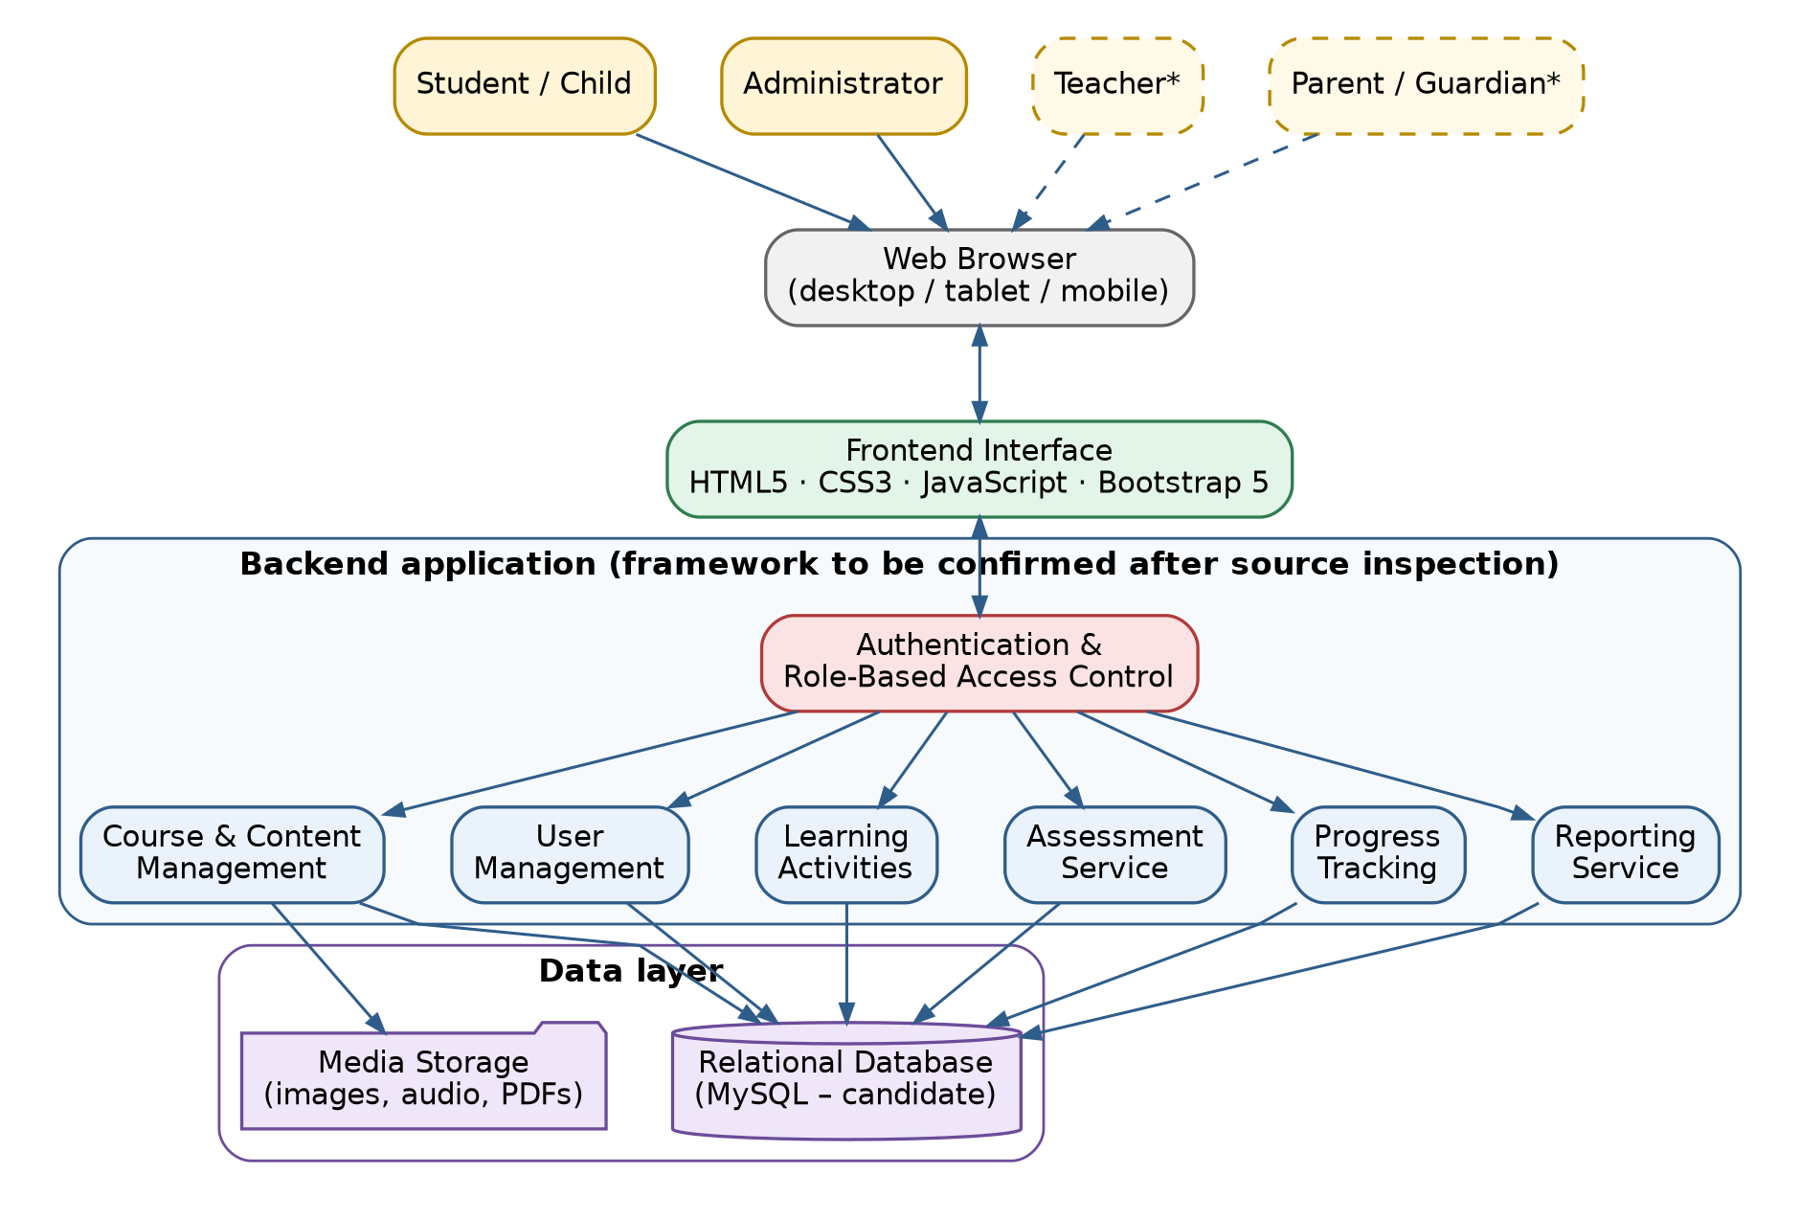
Figure 3.3.1 : System Architecture / Block Diagram

3.4 Flow Chart
Figure 2 shows the main learning workflow: login, role-based dashboard, course and lesson access, activity completion, optional assessment, saving of results, progress update and display of feedback.
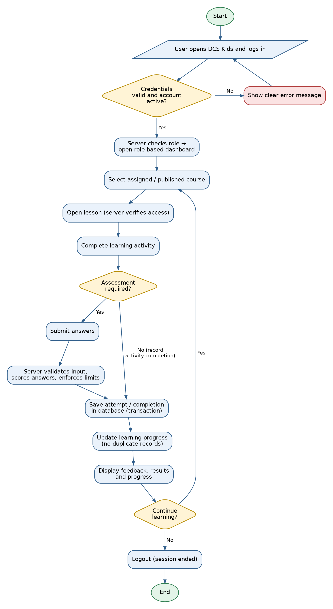
Figure 3.4.1 : Flow Chart (Learning Workflow)
3.5 Methodology
Design procedure. Requirements are first separated into verified features (observed on the live site or in source code), missing features and optional extensions. The architecture, data-flow diagrams (Figures 3 and 4), use-case diagram (Figure 5) and entity–relationship diagram (Figure 6) are then prepared. The ER model is normalised and uses primary and foreign keys, unique constraints (for example, one progress record per student and lesson) and indexes on frequently queried fields. The entities shown are proposed; only those required by the confirmed scope will be implemented.
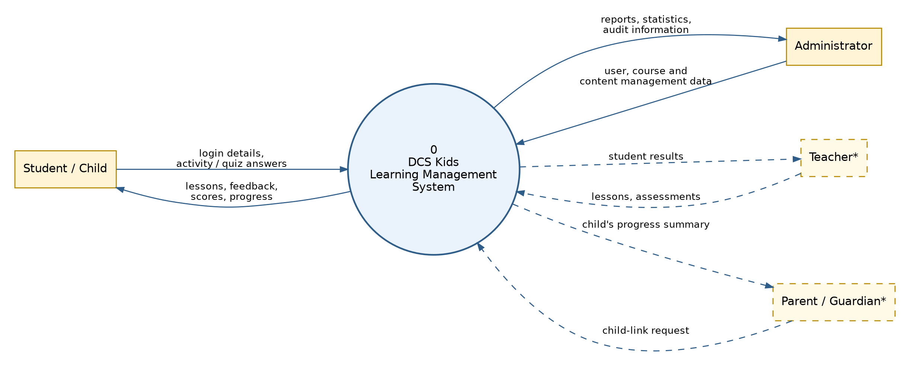
Figure 3.5.1 Data Flow Diagram (DFD 0)
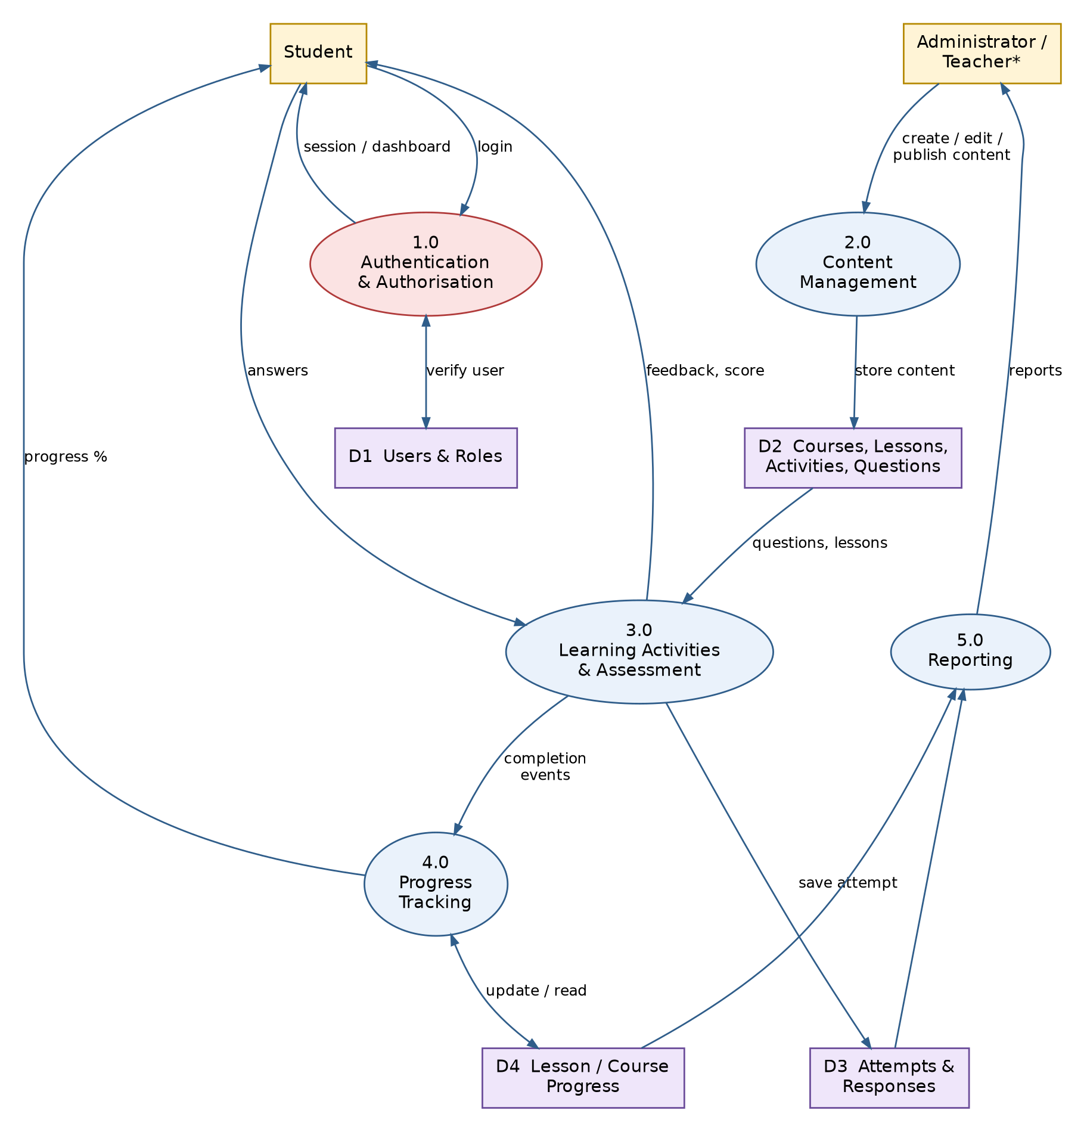
Figure 3.5.2 : Data Flow Diagram (DFD 1)
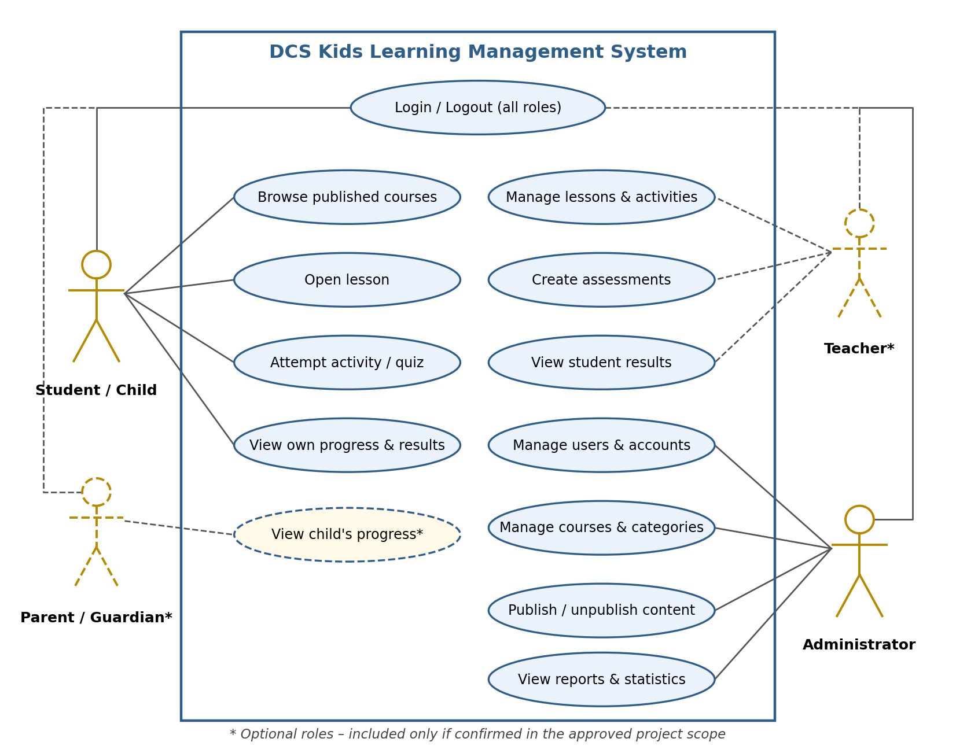

Figure 3.5.3 : Use Case Diagram
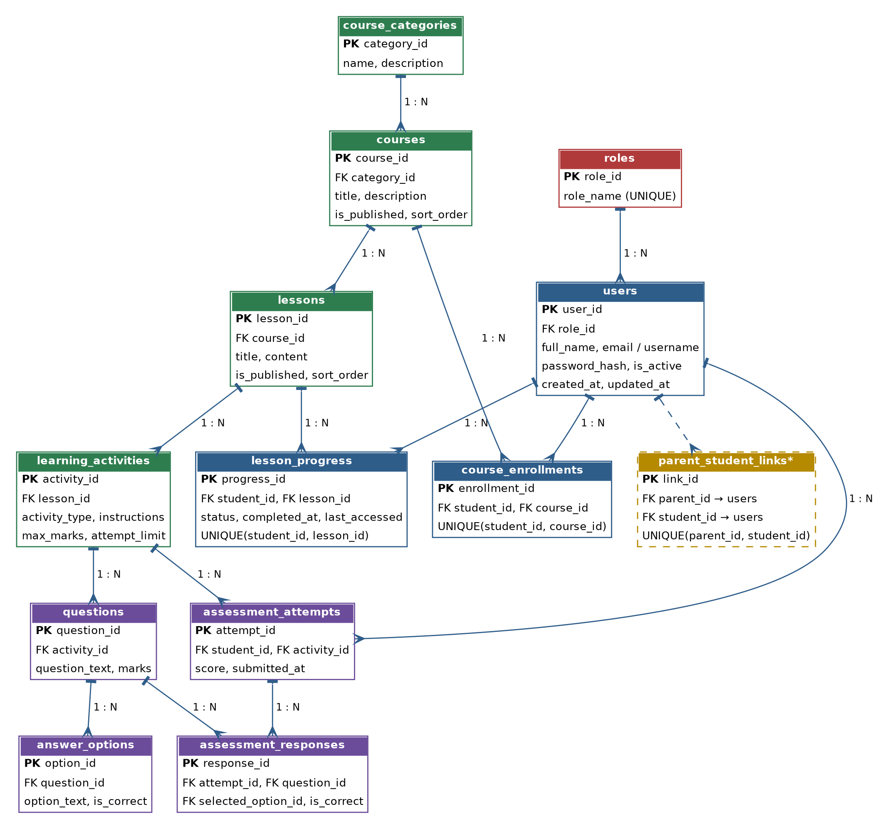
Figure 3.5.4 : ER Diagram

Development procedure: The system is built incrementally: project setup and configuration; authentication and role-based access; content management; learning activities and assessments; progress tracking and reporting; administrator features; and front-end integration. Every page, form and dashboard is connected to the back end and database, and no progress values or student records are hard-coded.
Algorithms: Two rules are implemented on the server:
Assessment scoring: score = sum of the marks of all questions answered correctly; percentage = score ÷ total marks × 100. The result is stored as the authoritative score.
Course progress: progress (%) = distinct lessons completed by the student ÷ published lessons in the course × 100. A unique constraint on (student, lesson) prevents duplicate completion records when a lesson is revisited.
Security and privacy procedure: Passwords are hashed; database access uses parameterised queries or an ORM; CSRF protection and output escaping are applied; file uploads are validated by type and size; HTTPS is used; only the minimum personal data is collected; and every protected route checks the user’s role, following OWASP guidance [15] and the DPDP Act, 2023 [17].
Testing procedure: Automated tests cover registration and login, authorisation, scoring, progress, CRUD operations and invalid input. Manual end-to-end tests cover the complete student workflow. Usability is reviewed against standard heuristics [14], accessibility against WCAG 2.1 [16], and layouts are checked on desktop, tablet and mobile screen sizes. Results will be documented honestly.
Programming steps: Configuration → models and migrations → services → routes/controllers → templates and front end → tests → documentation. Git is used for version control, backups are taken before significant changes, and production data is never overwritten for development convenience. As this is a software project, no manufacturing or physical experimental procedure is involved.

3.6 Components / Materials
Table 2: Components and software specification (candidate, subject to confirmation)
Component | Specification | Quantity
Development computer | Windows PC or laptop with VS Code and a modern web browser (team-owned) | One per team member
Front-end technologies | HTML5, CSS3, JavaScript, Bootstrap 5 (retained from the existing site) | 1 set
Back-end framework (candidate) | Python 3 with Flask; to be confirmed after source and hosting inspection | 1
Database (candidate) | MySQL with SQLAlchemy ORM and migration scripts | 1
Charts (optional) | Chart.js for progress and report charts | 1
Version control | Git | 1 repository
Testing tools | pytest (candidate) plus manual testing in Chrome, Firefox and Edge, including mobile viewports | 1 set
Hosting and domain | Existing dcsacademy.co.in hosting; compatibility with the chosen back end to be verified | 1
Configuration | Environment variables (.env) for secrets and database credentials | 1 per environment

CHAPTER 4: PROJECT PLANNING

4.1 Work Breakdown Structure
Table 3: Work breakdown structure
WBS | Work package | Main activities | Deliverable
1 | Requirements and analysis | Inspect the live site; request source, database and hosting access; list verified, missing and optional features; confirm roles and scope | Analysis report; requirements list
2 | Architecture and database design | Confirm the stack; design modules; prepare ER, DFD, use-case and flow diagrams; write schema and migrations | Design documents; schema
3 | Core development | Project setup; authentication and RBAC; content management; learning activities | Working core workflow
4 | Assessment and progress | Question bank; scoring; attempt limits; progress tracking; reports | Assessment and progress modules
5 | Dashboards and administration | Student dashboard; administrator dashboard; teacher/parent modules if approved | Role-based dashboards
6 | Security and testing | Validation; authorisation tests; privacy checks; end-to-end tests; bug fixing | Test report
7 | Documentation and deployment | README; setup guide; diagrams; deployment on the approved host | Final report; deployable build

4.2 Gantt Chart
The project is planned over a 16-week semester. The plan is indicative and will be adjusted to the academic calendar and to the access obtained to the existing project files.
Table 4: Gantt chart (numbers are semester weeks)
Work package | 1 | 2 | 3 | 4 | 5 | 6 | 7 | 8 | 9 | 10 | 11 | 12 | 13 | 14 | 15 | 16
1. Requirements and analysis
2. Architecture and database design
3. Core development
4. Assessment and progress
5. Dashboards and administration
6. Security and testing
7. Documentation and deployment

4.3 Roles and Responsibilities
Table 5: Roles and responsibilities (indicative; adjust to team size)
Student | Responsibility
Amandeep Gound | Project coordination; website and requirements analysis; back-end authentication, authorisation and APIs
Maviya Khot | Database design, models and migrations; course, assessment and progress services
Irfan Mansuri | Front-end UI/UX; student dashboard; learning activities; responsive and accessibility checks
Amandeep Gound | Testing and security validation; administrator dashboard support; documentation and diagrams
All Members | Integration, joint testing, report writing, presentation

4.4 Risk Assessment
Table 6: Risk assessment
Risk | Impact | Mitigation
Source code, database or hosting access is not provided | High – stack cannot be verified; rework may be needed | Request access early; document limitations; keep new modules compatible with the existing front end
Scope creep (teacher/parent modules not confirmed) | Medium | Confirm roles with the stakeholder; treat unconfirmed modules as optional
Breach or misuse of children’s personal data | High | Collect minimum data; hash passwords; enforce server-side RBAC; use HTTPS; follow DPDP Act obligations [17]
Hosting cannot run the chosen back end | Medium | Verify the environment before coding; adapt the stack or select a compatible host with approval
Loss or corruption of existing data during migration | High | Back up first; use version control; write non-destructive migrations; never overwrite production data
Insufficient learning content for activities | Medium | Reuse existing content; add small, clearly labelled demonstration content
Time overrun | Medium | Work in milestones; prioritise the core student workflow
Interface too complex for young learners | Medium | Use simple language, large touch targets and usability review [14]

CHAPTER 5: RESOURCES & FEASIBILITY

5.1 Technical Feasibility
All proposed tools (HTML5, CSS3, JavaScript, Bootstrap, Python/Flask, SQLAlchemy, MySQL, Git) are mature, open-source and well documented, and development is possible on Windows with VS Code. The existing front end can be reused. The main technical uncertainty is the hosting environment: if the current host cannot run the chosen back end, the stack will be adapted or a compatible host selected with approval. The project is therefore considered technically feasible, subject to confirmation of the existing source and hosting.

5.2 Economic Feasibility
No software licence fees are expected because the candidate tools are open-source, and the domain and hosting already exist (to be confirmed). The principal costs are incidental items such as report printing and backup storage, with an optional hosting upgrade if required (see Section 5.4). For a prototype serving a small academy, these costs are modest.

5.3 Operational Feasibility
Administrators and teachers will manage content through dashboards instead of editing HTML files. The interface is designed to be simple for children and efficient for adults, only a short orientation is expected to be needed, and modular code with backup and recovery guidance keeps the system maintainable. Role-based access limits the risk of accidental changes.

5.4 Budget Estimation
Table 7: Budget estimation (indicative; no quotations obtained)
Item | Quantity | Cost (₹, estimated)
Software (Python, Flask, SQLAlchemy, MySQL Community, VS Code, Git, Bootstrap, Chart.js) | 1 set | ₹0
Existing hosting and domain (dcsacademy.co.in) – to be confirmed | 1 | ₹0
SSL certificate (e.g., Let’s Encrypt, if not already active) | 1 | ₹0
Backup storage (cloud or external drive) | 1 | ₹1,000
Report printing and binding | 4 copies | ₹2,000
Contingency | – | ₹1,000
Subtotal (core) |  | ₹4,000
Optional: hosting upgrade (VPS or managed plan) if the existing host cannot run the back end | 1 year | ₹6,000
Total including optional item |  | ₹10,000

5.5 Bill of Materials (BOM)

Table 8: Bill of materials (software and services; candidates to be confirmed)
Sr. | Item | Specification / purpose | Licence / source
1 | Development computer | Windows PC/laptop, VS Code, modern browsers | Team-owned
2 | Python 3 | Programming language for the candidate back end | PSF licence (open source)
3 | Flask | Candidate web framework | BSD-3-Clause
4 | SQLAlchemy | ORM and parameterised database access | MIT
5 | MySQL Community Server | Candidate relational database | GPL v2
6 | Bootstrap 5 | Responsive front end (existing site uses a Bootstrap template) | MIT
7 | Chart.js (optional) | Progress and report charts | MIT
8 | Git | Version control and backups | GPL v2
9 | pytest (candidate) | Automated testing | MIT
10 | Web hosting and domain | Existing DCS Academy hosting (to be verified) | Existing

CHAPTER 6: EXPECTED RESULTS
The following are expected results and targets only. Actual results will be measured during implementation and reported in the final project report.
Table 9: Expected results and verification methods
Parameter | Expected result (target) | Verification
Working prototype | The LMS starts using the documented setup, and the core workflow (login → dashboard → lesson → activity → assessment → saved result → progress → report) works end to end. | End-to-end manual test
Functional correctness | All confirmed must-have features meet their acceptance criteria. | Checklist and automated tests
Scoring accuracy | Server-calculated scores match manual calculation in all test cases. | Test cases with known answers
Data consistency | No duplicate progress records; progress percentage matches actual completions. | Database checks and tests
Security | Protected pages and routes reject unauthenticated or unauthorised requests; passwords are stored hashed; invalid input is rejected safely. | Authorisation and input-validation tests
Performance | Typical pages load within about 3 seconds on a normal broadband connection (target). | Browser developer tools
Usability and accessibility | Usable on mobile, tablet and desktop; keyboard accessible; readable colour contrast (WCAG 2.1 AA target). | Manual review and checklists
Simulation / experiments | Not applicable (software project); a fictional demonstration dataset replaces physical experiments. | Seed data and test report

CHAPTER 7: SUSTAINABILITY & IMPACT
7.1 Industrial Relevance
Educational technology is an active field in which small academies, coaching centres and schools need affordable and secure platforms. The project shows how an existing static learning website can be upgraded into a managed LMS using open-source tools, which is relevant to web-development, EdTech and software-service organisations.

7.2 Societal Impact
The platform can widen access to structured Maths and English practice for children on ordinary phones, tablets and computers. Progress visibility helps teachers and, where approved, parents to support learning, and privacy-by-design practices protect children’s data. Gamification-style elements such as completion badges may be considered later, but their effects depend on context [8], [9].
7.3 Environmental Impact
Being software-only, the project needs no manufacturing. Digital activities and reports can reduce printed worksheets, and a lightweight application keeps hosting energy use low. The environmental impact is small; server energy use is the main footprint.
7.4 SDG Mapping
SDG 4 – Quality Education: interactive, trackable learning for children.
SDG 9 – Industry, Innovation and Infrastructure: open-source digital learning infrastructure.
SDG 10 – Reduced Inequalities: affordable, browser-based and mobile-friendly access.

CHAPTER 8: CONCLUSION
This synopsis proposes the transformation of DCS Kids from a collection of online learning activities into a complete, secure and responsive Learning Management System for children.
Problem: the public DCS Kids site shows no evidence of user accounts, saved results, role-based dashboards or progress tracking, and its back end has not yet been verified.
Proposed solution: an inspect-first, incremental development of authentication and RBAC, structured content, interactive activities, server-scored assessments, persistent progress tracking and dashboards, supported by a normalised database and a strong focus on children’s privacy.
Expected contribution: a runnable, documented and tested LMS that can be adopted by DCS Academy, together with a reusable approach and documentation for lightweight, privacy-aware learning platforms for children.

REFERENCES
[1] F. D. Davis, “Perceived usefulness, perceived ease of use, and user acceptance of information technology,” MIS Quarterly, vol. 13, no. 3, pp. 319–340, 1989.
[2] M. Dougiamas and P. C. Taylor, “Moodle: Using learning communities to create an open source course management system,” in Proc. EDMEDIA 2003, Honolulu, HI, USA, 2003.
[3] E. Dahlstrom, D. C. Brooks, and J. Bichsel, “The current ecosystem of learning management systems in higher education: Student, faculty, and IT perspectives,” EDUCAUSE Center for Applied Research, Louisville, CO, USA, Res. Rep., 2014.
[4] V. M. Bradley, “Learning management system (LMS) use with online instruction,” Int. J. Technol. Educ. (IJTE), vol. 4, no. 1, pp. 68–92, 2021, doi: 10.46328/ijte.36.
[5] U. Alturki and A. Aldraiweesh, “Application of learning management system (LMS) during the COVID-19 pandemic: A sustainable acceptance model of the expansion technology approach,” Sustainability, vol. 13, no. 19, Art. no. 10991, 2021, doi: 10.3390/su131910991.
[6] N. Cavus, Y. B. Mohammed, and M. N. Yakubu, “Determinants of learning management systems during COVID-19 pandemic for sustainable education,” Sustainability, vol. 13, no. 9, Art. no. 5189, 2021.
[7] K. Hirsh-Pasek, J. M. Zosh, R. M. Golinkoff, J. H. Gray, M. B. Robb, and J. Kaufman, “Putting education in ‘educational’ apps: Lessons from the science of learning,” Psychol. Sci. Public Interest, vol. 16, no. 1, pp. 3–34, 2015.
[8] J. Hamari, J. Koivisto, and H. Sarsa, “Does gamification work? A literature review of empirical studies on gamification,” in Proc. 47th Hawaii Int. Conf. Syst. Sci. (HICSS), Waikoloa, HI, USA, 2014, pp. 3025–3034.
[9] S. Deterding, D. Dixon, R. Khaled, and L. Nacke, “From game design elements to gamefulness: Defining ‘gamification’,” in Proc. 15th Int. Acad. MindTrek Conf., Tampere, Finland, 2011, pp. 9–15.
[10] P. Black and D. Wiliam, “Assessment and classroom learning,” Assessment in Education: Principles, Policy & Practice, vol. 5, no. 1, pp. 7–74, 1998.
[11] R. E. Mayer, Multimedia Learning, 2nd ed. Cambridge, U.K.: Cambridge Univ. Press, 2009.
[12] J. Sweller, “Cognitive load during problem solving: Effects on learning,” Cognitive Science, vol. 12, no. 2, pp. 257–285, 1988.
[13] R. M. Ryan and E. L. Deci, “Self-determination theory and the facilitation of intrinsic motivation, social development, and well-being,” American Psychologist, vol. 55, no. 1, pp. 68–78, 2000.
[14] J. Nielsen, Usability Engineering. San Diego, CA, USA: Academic Press, 1993.
[15] OWASP Foundation, “OWASP Top 10:2021.” [Online]. Available: https://owasp.org/Top10/
[16] W3C, “Web Content Accessibility Guidelines (WCAG) 2.1,” W3C Recommendation, Jun. 2018. [Online]. Available: https://www.w3.org/TR/WCAG21/
[17] Government of India, “The Digital Personal Data Protection Act, 2023,” Act No. 22 of 2023, 2023.
[18] DCS Kids, “DCS Kids – Online learning platform.” [Online]. Available: https://dcskids.dcsacademy.co.in/ (accessed Oct. 19, 2026).

